Function 8:
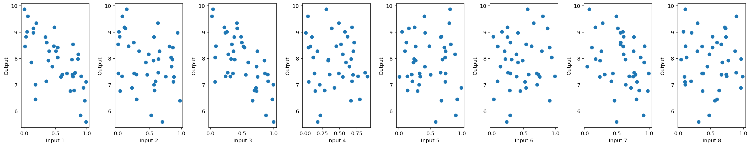
Input 1 and Input 3 and 7 (with lots of noise) inversly proportional to output

Week 14
Function 1:
Kappa 2 predicted next best prediction
function_1: next point to submit -> [0.7586 0.799 ] (UCB=0.0018)
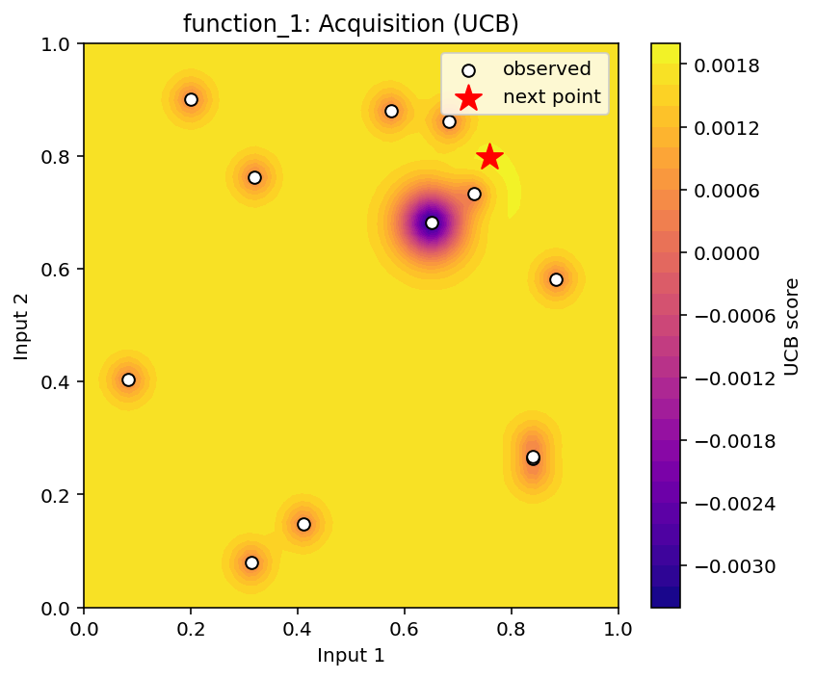
Kappa10 predicted next best point
function_1: next point to submit -> [0.7957 0.8159] (UCB=0.0098)
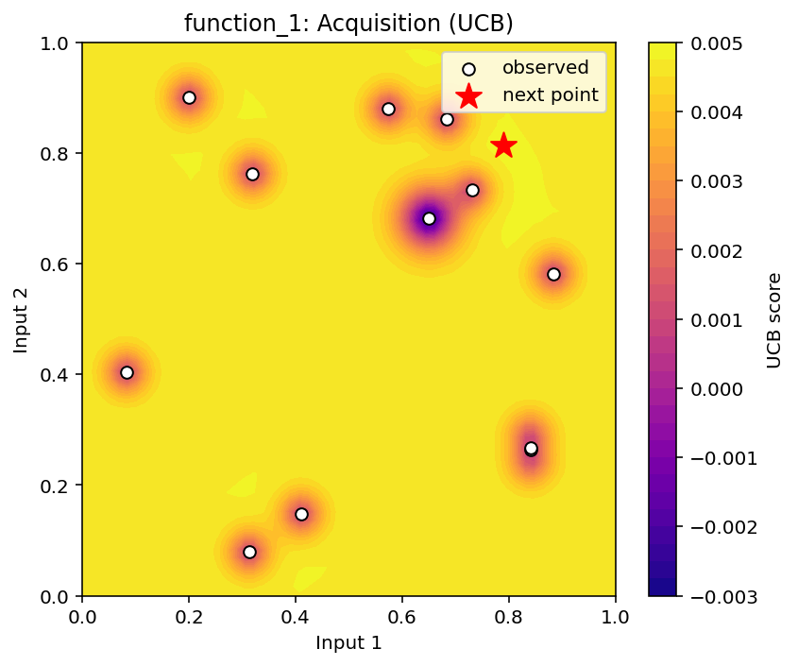

But I want to use this early phase for checking completely unexplored areas like 0.5-0.4. Hence going with that submission

======================================================================
EVALUATION OF PREVIOUS SUBMISSIONS
======================================================================

======================================================================
WEEK 1
======================================================================
1**2 * RBF(length_scale=0.000363) + WhiteKernel(noise_level=0.000363)

function_1
----------------------------------------
Submitted point : [0.2 0.9]
Predicted output: -0.000361
Predicted std : 0.001082
UCB : 0.001803
Actual output : 0.000000
Absolute error : 0.000361
Previous best : 0.000000
Improvement : -0.000000
Result : MATCHED BEST
Min: -0.0036060626443634764
Max: 7.710875114502849e-16
Mean: -0.00036060626443627054
Std: 0.0010818187933090686
Prediction accuracy: 0.00036060626443627054
Improvement over previous best: -7.710875114502849e-16
Whether it matched the best: True
Exploration contribution: 0.002163637585126098

======================================================================
WEEK 2
======================================================================
1**2 * RBF(length_scale=0.00133) + WhiteKernel(noise_level=0.000657)

function_1
----------------------------------------
Submitted point : [0.8403 0.2672]
Predicted output: -0.000270
Predicted std : 0.001020
UCB : 0.001771
Actual output : 0.000000
Absolute error : 0.000270
Previous best : 0.000000
Improvement : -0.000000
Result : MATCHED BEST
Min: -0.0036060626443634764
Max: 7.710875114502849e-16
Mean: -0.00036060626443627054
Std: 0.0010818187933090686
Prediction accuracy: 0.00026955209469776433
Improvement over previous best: -7.710875114502849e-16
Whether it matched the best: True
Exploration contribution: 0.0020403224652995053

I kept κ fixed at 2 to maintain a consistent exploration-exploitation trade-off, but the GP hyperparameters were re-optimised automatically as new observations became available. For example, the RBF length scale increased from 0.000363 in Week 1 to 0.00133 in Week 2, while the estimated noise level increased from 0.000363 to 0.000657. This means the GP's understanding of the smoothness and variability of the response surface changed as more data became available, even though my acquisition-function strategy remained fixed

Function2
My week 2 prediction was
Predicted output = 0.273
Predicted std = 0.231
UCB = 0.735
Actual output = 0
So unfortunately, the point didn't turn out to be good.
But that doesn't mean the UCB calculation was wrong.

The GP believed the region was potentially valuable, but the uncertainty was high enough that it was worth investigating. The actual observation then provided information that this region was less promising than the model had expected.
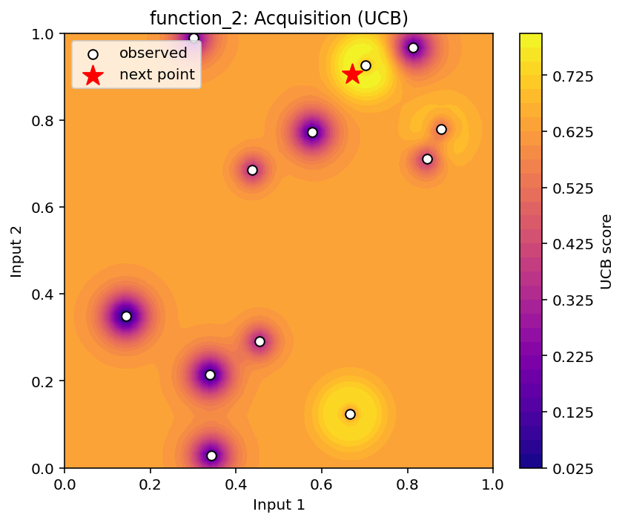

WEEK 3
Function | How it is performing | What the model is doing | Week 3 submission
F1 | Very well understood | Extremely low uncertainty; mainly exploitation | [0.7586, 0.7990]
F2 | Still uncertain, but improving | Moving towards a promising region; more exploitation than before | [0.6702, 0.9052]
F3 | Good GP fit and relatively low uncertainty | Balanced but increasingly exploitative | [0.3806, 0.0351, 0.5179]
F4 | Major improvement after Week 2 | Model has learned that positive-output regions are valuable; strong exploitation | [0.3991, 0.4509, 0.3858, 0.4157]
F5 | Most difficult/uncertain function | Very high uncertainty → aggressive exploration + exploitation | [0.9322, 0.9281, 0.9819, 0.9831]
F6 | GP is very confident | Very low uncertainty → mostly exploitation | [0.3999, 0.1452, 0.6117, 0.9247, 0.2415]
F7 | Reasonably well understood | Moderate uncertainty; balanced exploration/exploitation | [0.0218, 0.4447, 0.1262, 0.2447, 0.2003, 0.6901]
F8 | Good GP performance | Relatively confident, targeting a high-value region | [0.2473, 0.6117, 0.1577, 0.0721, 0.9899, 0.0001, 0.0263, 0.0880]
1. Function 1 — model is now extremely confident
The GP has essentially zero in-sample error:
- Mean absolute error: 0.000000
- Average uncertainty: 0.000004
- New UCB: 0.0018
The recommended point is:
[0.7586, 0.7990]
This is a clear exploitation strategy. The GP doesn't think there is much uncertainty left, so κ = 2 doesn't contribute much to the UCB.
This is very different from early rounds, when the model had much higher uncertainty.
Influence on Week 3:
The latest submission is being driven almost entirely by the GP's estimated mean rather than exploration.

2. Function 2 — still searching, but becoming more focused
Function 2 has been difficult.
Its previous best is 0.6112, while earlier submissions sometimes produced much lower values. In Week 2, for example, the model predicted 0.563, but the actual result was only 0.0523.
Now the GP has:
- Very low in-sample error
- Average uncertainty: 0.000959
- Week 3 UCB: 0.7969
And it recommends:
[0.6702, 0.9052]
So the model has moved away from the previous unsuccessful areas and is targeting another region with potentially higher output.
Influence on Week 3:
The latest submission is more exploitative than the first two weeks, because the GP has learned from those failed queries.

3. Function 3 — relatively stable and well understood
Function 3's GP has:
- MAE = 0.00434
- Maximum error = 0.01243
- Average uncertainty = 0.0242
The recommended point is:
[0.3806, 0.0351, 0.5179]
with UCB:
0.1009
The Week 2 submission actually improved the best value, from -0.0348 to -0.0220.
Remember that for this function, higher is better, so moving from -0.0348 to -0.0220 was an improvement.
Influence on Week 3:
Because the model now has relatively low uncertainty and has already found an improvement, it is becoming more confident and is focusing on promising regions rather than randomly exploring.

4. Function 4 — probably the most interesting improvement
Function 4 had a poor first submission, but Week 2 was a major success.
Week 2:
Predicted = -1.262
Actual = +0.350
and the best value jumped from -4.026 to +0.350.
That's a huge improvement.
Now the GP recommends:
[0.3991, 0.4509, 0.3858, 0.4157]
with:
UCB = 0.7429
The model is therefore trying to find another region around the newly discovered positive area.
Influence on Week 3:
This is a good example of learning from exploration. Week 2 discovered a surprisingly good region, and the Week 3 submission is now trying to exploit that knowledge.

5. Function 5 — 🚨 the big one
Function 5 is by far the most uncertain function.
Its statistics are:
MAE = 53.91
Maximum error = 293.87
Average std = 204.32
Compare that with Function 1's uncertainty of only 0.000004.
That's an enormous difference.
Also, Week 2 was spectacular:
Previous best = 1088.86
Actual = 2693.68
So the algorithm found a massive improvement in Week 2.
Now the GP recommends:
[0.9322, 0.9281, 0.9819, 0.9831]
with:
UCB = 3769.56
That's extremely high.
Influence on Week 3:
The model is saying:
"The high-value region we found is extremely promising, but I'm still uncertain about the exact shape of this region. Let's investigate very high input values."
So this is a combination of exploitation of the promising region + exploration within it.
This is probably your strongest example of UCB working as intended.

6. Function 6 — very confident, mainly exploitation
Function 6 has:
MAE = 0.000007
Max error = 0.000021
Average uncertainty = 0.002206
The Week 3 point is:
[0.3999, 0.1452, 0.6117, 0.9247, 0.2415]
with UCB:
0.0016
The GP is extremely confident compared with Function 5.
Interestingly, Week 1 had actually improved the best from -0.714 to -0.339, but Week 2 moved in the wrong direction to -1.221.
Influence on Week 3:
The low uncertainty means UCB isn't giving much additional weight to exploration. The model is therefore primarily exploiting what it has learned.

7. Function 7 — reasonably good but still some exploration
Function 7 has:
MAE = 0.0163
Average uncertainty = 0.1038
and the recommended point is:
[0.0218, 0.4447, 0.1262, 0.2447, 0.2003, 0.6901]
with:
UCB = 1.5301
The existing best is 1.3650.
Week 2 got quite close to that best, producing 1.3142, although it didn't beat it.
Influence on Week 3:
The model is not completely confident, so UCB still encourages exploration, but the submission is clearly trying to find a value above the current best.

8. Function 8 — strong and relatively reliable
Function 8 has:
MAE = 0.0329
Average uncertainty = 0.1446
The latest point is:
[0.2473, 0.6117, 0.1577, 0.0721,
0.9899, 0.0001, 0.0263, 0.0880]
with:
UCB = 10.6427
The current best is 9.8683.
This function has already shown that the GP can predict it reasonably well. In Week 2, the prediction was 9.9393 and the actual was 9.7795, an error of only 0.1598.
Influence on Week 3:
The model is targeting another potentially high-output region, but it still retains some exploration because there is uncertainty around the optimum.

The big picture for Week 3
I'd categorise your eight functions like this:
🟢 Mainly exploitation
F1, F3, F6
The GP has become confident, so κ = 2 doesn't add much uncertainty to the UCB.
🟡 Balanced exploration/exploitation
F2, F4, F7, F8
The model has learned useful information but still has enough uncertainty to investigate alternative promising regions.
🔴 Strong exploration + exploitation
F5
Function 5 is the standout. It has both very high predicted potential and enormous uncertainty, so UCB is aggressively targeting the upper-right part of the input space.

A good capstone summary
"By Week 3, the behaviour of the UCB strategy had become function-specific. For Functions 1, 3 and 6, the GP had become highly confident, with very low prediction errors and uncertainty, so the latest submissions were primarily driven by exploitation. Functions 2, 4, 7 and 8 retained a moderate level of uncertainty, resulting in a balance between exploiting known promising regions and exploring alternatives. Function 5 remained substantially more uncertain than the others. Following a very large improvement in Week 2, where the best output increased from approximately 1089 to 2694, the Week 3 acquisition function targeted an even higher-value region while retaining significant exploration. Overall, the latest submissions show that although κ remained fixed at 2, the exploration-exploitation balance changed naturally across functions because the GP's estimated uncertainty differed between them."
One important caveat: the tiny MAEs above are training-fit errors, so don't say "the GP predicts new points accurately" based on those alone. Your separate previous-submission evaluation is the correct evidence for out-of-sample prediction accuracy.

Week 4

%runfile 'C:/Data Science and AI/Capstone Project/Week3/Capstone project week 4.py' --wdir

Loading Week 1 data...
Inputs: C:/Data Science and AI/Capstone Project/Week1/Data/inputs.txt
Outputs: C:/Data Science and AI/Capstone Project/Week1/Data/outputs.txt
First part of inputs.txt:
[array([0.2, 0.9]), array([0.3 , 0.99]), array([0.9 , 0.55, 0.7 ]), array([0.75, 0.3 , 0.1 , 0.35]), array([0.25, 0.3 , 0.9 , 0.7 ]), array([0.333928, 0.269355, 0.490232, 0.738473, 0.049508]), array([0.06594 , 0.52139 , 0.332424, 0.216678, 0.44375 , 0.86162 ]), array([0.000833, 0.139858, 0.037736, 0
First part of outputs.txt:
[5.711328105760199e-181, 0.08822150601091024, -0.11615319691256885, -12.45679365763927, 136.92002496639998, -0.33916818668127346, 0.950192197764855, 9.868343757758]

Loading Week 2 data...
Inputs: C:/Data Science and AI/Capstone Project/Week2/Data/inputs.txt
Outputs: C:/Data Science and AI/Capstone Project/Week2/Data/outputs.txt
First part of inputs.txt:
[array([0.8403, 0.2672]), array([0.8133, 0.9669]), array([0.4426, 0.3666, 0.5041]), array([0.4326, 0.4333, 0.3436, 0.425 ]), array([0.4054, 0.9465, 0.9911, 0.8934]), array([0.1662, 0.4609, 0.0496, 0.9864, 0.0088]), array([0.1025, 0.39 , 0.1904, 0.1203, 0.3667, 0.8232]), array([0.1187, 0.0644, 0.190
First part of outputs.txt:
[4.672024099202534e-123, 0.052251532879293926, -0.021971627219766462, 0.3499931771236189, 2693.675236976868, -1.221208578037427, 1.3141986780566581, 9.779453256]

Loading Week 3 data...
Inputs: C:/Data Science and AI/Capstone Project/Week3/Data/inputs.txt
Outputs: C:/Data Science and AI/Capstone Project/Week3/Data/outputs.txt
First part of inputs.txt:
[array([0.7586, 0.799 ]), array([0.6702, 0.9052]), array([0.3806, 0.0351, 0.5179]), array([0.3991, 0.4509, 0.3858, 0.4157]), array([0.9322, 0.9281, 0.9819, 0.9831]), array([0.3999, 0.1452, 0.6117, 0.9247, 0.2415]), array([0.0218, 0.4447, 0.1262, 0.2447, 0.2003, 0.6901]), array([2.473e-01, 6.117e-01,
First part of outputs.txt:
[9.192930310167125e-33, 0.579882509178802, -0.09131086489610549, -0.16538673271309134, 5840.000772443907, -0.6024608125944072, 1.4340429307922657, 9.380579455]
1.01**2 * RBF(length_scale=0.0488) + WhiteKernel(noise_level=1e-05)
C:\Users\talkg\anaconda3\Lib\site-packages\sklearn\gaussian_process\kernels.py:440: ConvergenceWarning: The optimal value found for dimension 0 of parameter k2__noise_level is close to the specified lower bound 1e-05. Decreasing the bound and calling fit again may find a better value.
warnings.warn(

function_1 GP fit statistics
--------------------------------------------------
Mean absolute error: 0.000000
Maximum absolute error: 0.000000
Average GP uncertainty: 0.000004
function_1: next point to submit -> [0.8012 0.7195] (UCB=0.0018)
0.932**2 * RBF(length_scale=0.0642) + WhiteKernel(noise_level=1e-05)
C:\Users\talkg\anaconda3\Lib\site-packages\sklearn\gaussian_process\kernels.py:440: ConvergenceWarning: The optimal value found for dimension 0 of parameter k2__noise_level is close to the specified lower bound 1e-05. Decreasing the bound and calling fit again may find a better value.
warnings.warn(

function_2 GP fit statistics
--------------------------------------------------
Mean absolute error: 0.000002
Maximum absolute error: 0.000005
Average GP uncertainty: 0.001024
function_2: next point to submit -> [0.6637 0.97 ] (UCB=0.8177)
1.09**2 * RBF(length_scale=0.226) + WhiteKernel(noise_level=0.0402)

function_3 GP fit statistics
--------------------------------------------------
Mean absolute error: 0.003463
Maximum absolute error: 0.010877
Average GP uncertainty: 0.022066
function_3: next point to submit -> [0.7125 0.9846 0.0259] (UCB=0.0847)
1.64**2 * RBF(length_scale=0.654) + WhiteKernel(noise_level=0.000829)

function_4 GP fit statistics
--------------------------------------------------
Mean absolute error: 0.030744
Maximum absolute error: 0.251405
Average GP uncertainty: 0.316413
function_4: next point to submit -> [0.4326 0.4333 0.3436 0.4259] (UCB=0.6795)
1.71**2 * RBF(length_scale=0.752) + WhiteKernel(noise_level=1e-05)
C:\Users\talkg\anaconda3\Lib\site-packages\sklearn\gaussian_process\kernels.py:440: ConvergenceWarning: The optimal value found for dimension 0 of parameter k2__noise_level is close to the specified lower bound 1e-05. Decreasing the bound and calling fit again may find a better value.
warnings.warn(

function_5 GP fit statistics
--------------------------------------------------
Mean absolute error: 0.056643
Maximum absolute error: 0.177340
Average GP uncertainty: 5.679017
function_5: next point to submit -> [0.9322 0.9281 0.9819 0.9831] (UCB=5850.8087)
1.01**2 * RBF(length_scale=0.49) + WhiteKernel(noise_level=1e-05)
C:\Users\talkg\anaconda3\Lib\site-packages\sklearn\gaussian_process\kernels.py:440: ConvergenceWarning: The optimal value found for dimension 0 of parameter k2__noise_level is close to the specified lower bound 1e-05. Decreasing the bound and calling fit again may find a better value.
warnings.warn(

function_6 GP fit statistics
--------------------------------------------------
Mean absolute error: 0.000008
Maximum absolute error: 0.000024
Average GP uncertainty: 0.002285
function_6: next point to submit -> [0.2347 0.0573 0.7225 0.5628 0.0484] (UCB=-0.0743)
0.791**2 * RBF(length_scale=0.312) + WhiteKernel(noise_level=1e-05)
C:\Users\talkg\anaconda3\Lib\site-packages\sklearn\gaussian_process\kernels.py:440: ConvergenceWarning: The optimal value found for dimension 0 of parameter k2__noise_level is close to the specified lower bound 1e-05. Decreasing the bound and calling fit again may find a better value.
warnings.warn(

function_7 GP fit statistics
--------------------------------------------------
Mean absolute error: 0.000005
Maximum absolute error: 0.000026
Average GP uncertainty: 0.001853
function_7: next point to submit -> [0.0403 0.388 0.0797 0.2724 0.2763 0.5336] (UCB=1.6588)
1.81**2 * RBF(length_scale=1.47) + WhiteKernel(noise_level=0.0127)

function_8 GP fit statistics
--------------------------------------------------
Mean absolute error: 0.038083
Maximum absolute error: 0.144320
Average GP uncertainty: 0.156349
function_8: next point to submit -> [0.1178 0.6198 0.0085 0.3535 0.9749 0.8255 0.1569 0.551 ] (UCB=10.6523)

======================================================================
EVALUATION OF PREVIOUS SUBMISSIONS
======================================================================

Loading Week 1 data...
Inputs: C:/Data Science and AI/Capstone Project/Week1/Data/inputs.txt
Outputs: C:/Data Science and AI/Capstone Project/Week1/Data/outputs.txt
First part of inputs.txt:
[array([0.2, 0.9]), array([0.3 , 0.99]), array([0.9 , 0.55, 0.7 ]), array([0.75, 0.3 , 0.1 , 0.35]), array([0.25, 0.3 , 0.9 , 0.7 ]), array([0.333928, 0.269355, 0.490232, 0.738473, 0.049508]), array([0.06594 , 0.52139 , 0.332424, 0.216678, 0.44375 , 0.86162 ]), array([0.000833, 0.139858, 0.037736, 0
First part of outputs.txt:
[5.711328105760199e-181, 0.08822150601091024, -0.11615319691256885, -12.45679365763927, 136.92002496639998, -0.33916818668127346, 0.950192197764855, 9.868343757758]

======================================================================
WEEK 1
======================================================================
1**2 * RBF(length_scale=0.000363) + WhiteKernel(noise_level=0.000363)

function_1
----------------------------------------
Submitted point : [0.2 0.9]
Predicted output: -0.000361
Predicted std : 0.001082
UCB : 0.001803
Actual output : 0.000000
Absolute error : 0.000361
Previous best : 0.000000
Improvement : -0.000000
Result : MATCHED BEST
Exploration contribution: 0.002164
Data statistics after Week 1:
Min : -0.003606
Max : 0.000000
Mean: -0.000328
Std : 0.001037
C:\Users\talkg\anaconda3\Lib\site-packages\sklearn\gaussian_process\kernels.py:440: ConvergenceWarning: The optimal value found for dimension 0 of parameter k2__noise_level is close to the specified lower bound 1e-05. Decreasing the bound and calling fit again may find a better value.
warnings.warn(
1.06**2 * RBF(length_scale=0.131) + WhiteKernel(noise_level=1e-05)

function_2
----------------------------------------
Submitted point : [0.3 0.99]
Predicted output: 0.230475
Predicted std : 0.238720
UCB : 0.707915
Actual output : 0.088222
Absolute error : 0.142253
Percentage error: 161.25%
Previous best : 0.611205
Improvement : -0.522984
Result : DID NOT IMPROVE BEST
Exploration contribution: 0.477440
Data statistics after Week 1:
Min : -0.065624
Max : 0.611205
Mean: 0.217724
Std : 0.218744
1.1**2 * RBF(length_scale=0.228) + WhiteKernel(noise_level=0.0578)

function_3
----------------------------------------
Submitted point : [0.9 0.55 0.7 ]
Predicted output: -0.087681
Predicted std : 0.087039
UCB : 0.086397
Actual output : -0.116153
Absolute error : 0.028472
Percentage error: 24.51%
Previous best : -0.034835
Improvement : -0.081318
Result : DID NOT IMPROVE BEST
Exploration contribution: 0.174079
Data statistics after Week 1:
Min : -0.398926
Max : -0.034835
Mean: -0.107729
Std : 0.081569
C:\Users\talkg\anaconda3\Lib\site-packages\sklearn\gaussian_process\kernels.py:440: ConvergenceWarning: The optimal value found for dimension 0 of parameter k2__noise_level is close to the specified lower bound 1e-05. Decreasing the bound and calling fit again may find a better value.
warnings.warn(
2.04**2 * RBF(length_scale=0.724) + WhiteKernel(noise_level=1e-05)

function_4
----------------------------------------
Submitted point : [0.75 0.3 0.1 0.35]
Predicted output: -10.183568
Predicted std : 1.770330
UCB : -6.642907
Actual output : -12.456794
Absolute error : 2.273226
Percentage error: 18.25%
Previous best : -4.025542
Improvement : -8.431251
Result : DID NOT IMPROVE BEST
Exploration contribution: 3.540660
Data statistics after Week 1:
Min : -32.625660
Max : -4.025542
Mean: -17.084336
Std : 6.955368
1.39**2 * RBF(length_scale=0.608) + WhiteKernel(noise_level=0.172)

function_5
----------------------------------------
Submitted point : [0.25 0.3 0.9 0.7 ]
Predicted output: 418.264583
Predicted std : 188.802946
UCB : 795.870475
Actual output : 136.920025
Absolute error : 281.344558
Percentage error: 205.48%
Previous best : 1088.859618
Improvement : -951.939593
Result : DID NOT IMPROVE BEST
Exploration contribution: 377.605892
Data statistics after Week 1:
Min : 0.112940
Max : 1088.859618
Mean: 150.588454
Std : 239.677106
1.13**2 * RBF(length_scale=0.509) + WhiteKernel(noise_level=0.0252)

function_6
----------------------------------------
Submitted point : [0.3339 0.2694 0.4902 0.7385 0.0495]
Predicted output: -0.583678
Predicted std : 0.313649
UCB : 0.043620
Actual output : -0.339168
Absolute error : 0.244510
Percentage error: 72.09%
Previous best : -0.714265
Improvement : 0.375097
Result : IMPROVED BEST
Exploration contribution: 0.627298
Data statistics after Week 1:
Min : -2.571170
Max : -0.339168
Mean: -1.440332
Std : 0.502622
C:\Users\talkg\anaconda3\Lib\site-packages\sklearn\gaussian_process\kernels.py:440: ConvergenceWarning: The optimal value found for dimension 0 of parameter k2__noise_level is close to the specified lower bound 1e-05. Decreasing the bound and calling fit again may find a better value.
warnings.warn(
0.995**2 * RBF(length_scale=0.28) + WhiteKernel(noise_level=1e-05)

function_7
----------------------------------------
Submitted point : [0.0659 0.5214 0.3324 0.2167 0.4438 0.8616]
Predicted output: 1.193470
Predicted std : 0.158907
UCB : 1.511284
Actual output : 0.950192
Absolute error : 0.243278
Percentage error: 25.60%
Previous best : 1.364968
Improvement : -0.414776
Result : DID NOT IMPROVE BEST
Exploration contribution: 0.317814
Data statistics after Week 1:
Min : 0.002701
Max : 1.364968
Mean: 0.243174
Std : 0.324037
2.02**2 * RBF(length_scale=1.5) + WhiteKernel(noise_level=0.0172)

function_8
----------------------------------------
Submitted point : [8.000e-04 1.399e-01 3.770e-02 3.046e-01 8.078e-01 5.586e-01 6.790e-02
1.094e-01]
Predicted output: 10.304858
Predicted std : 0.460380
UCB : 11.225617
Actual output : 9.868344
Absolute error : 0.436514
Percentage error: 4.42%
Previous best : 9.598482
Improvement : 0.269862
Result : IMPROVED BEST
Exploration contribution: 0.920759
Data statistics after Week 1:
Min : 5.592193
Max : 9.868344
Mean: 7.865349
Std : 0.987450

Loading Week 2 data...
Inputs: C:/Data Science and AI/Capstone Project/Week2/Data/inputs.txt
Outputs: C:/Data Science and AI/Capstone Project/Week2/Data/outputs.txt
First part of inputs.txt:
[array([0.8403, 0.2672]), array([0.8133, 0.9669]), array([0.4426, 0.3666, 0.5041]), array([0.4326, 0.4333, 0.3436, 0.425 ]), array([0.4054, 0.9465, 0.9911, 0.8934]), array([0.1662, 0.4609, 0.0496, 0.9864, 0.0088]), array([0.1025, 0.39 , 0.1904, 0.1203, 0.3667, 0.8232]), array([0.1187, 0.0644, 0.190
First part of outputs.txt:
[4.672024099202534e-123, 0.052251532879293926, -0.021971627219766462, 0.3499931771236189, 2693.675236976868, -1.221208578037427, 1.3141986780566581, 9.779453256]

======================================================================
WEEK 2
======================================================================
1**2 * RBF(length_scale=0.00133) + WhiteKernel(noise_level=0.000657)

function_1
----------------------------------------
Submitted point : [0.8403 0.2672]
Predicted output: -0.000270
Predicted std : 0.001020
UCB : 0.001771
Actual output : 0.000000
Absolute error : 0.000270
Previous best : 0.000000
Improvement : -0.000000
Result : MATCHED BEST
Exploration contribution: 0.002040
Data statistics after Week 2:
Min : -0.003606
Max : 0.000000
Mean: -0.000301
Std : 0.000997
1.05**2 * RBF(length_scale=0.125) + WhiteKernel(noise_level=1e-05)

function_2
----------------------------------------
Submitted point : [0.8133 0.9669]
Predicted output: 0.563117
Predicted std : 0.164287
UCB : 0.891690
Actual output : 0.052252
Absolute error : 0.510865
Percentage error: 977.70%
Previous best : 0.611205
Improvement : -0.558954
Result : DID NOT IMPROVE BEST
Exploration contribution: 0.328573
Data statistics after Week 2:
Min : -0.065624
Max : 0.611205
Mean: 0.203934
Std : 0.214367
1.08**2 * RBF(length_scale=0.221) + WhiteKernel(noise_level=0.0626)

function_3
----------------------------------------
Submitted point : [0.4426 0.3666 0.5041]
Predicted output: -0.042691
Predicted std : 0.072043
UCB : 0.101395
Actual output : -0.021972
Absolute error : 0.020720
Percentage error: 94.30%
Previous best : -0.034835
Improvement : 0.012864
Result : IMPROVED BEST
Exploration contribution: 0.144086
Data statistics after Week 2:
Min : -0.398926
Max : -0.021972
Mean: -0.102684
Std : 0.081665
C:\Users\talkg\anaconda3\Lib\site-packages\sklearn\gaussian_process\kernels.py:440: ConvergenceWarning: The optimal value found for dimension 0 of parameter k2__noise_level is close to the specified lower bound 1e-05. Decreasing the bound and calling fit again may find a better value.
warnings.warn(
C:\Users\talkg\anaconda3\Lib\site-packages\sklearn\gaussian_process\kernels.py:440: ConvergenceWarning: The optimal value found for dimension 0 of parameter k2__noise_level is close to the specified lower bound 1e-05. Decreasing the bound and calling fit again may find a better value.
warnings.warn(
1.94**2 * RBF(length_scale=0.696) + WhiteKernel(noise_level=1e-05)

function_4
----------------------------------------
Submitted point : [0.4326 0.4333 0.3436 0.425 ]
Predicted output: -1.261978
Predicted std : 0.585754
UCB : -0.090470
Actual output : 0.349993
Absolute error : 1.611971
Percentage error: 460.57%
Previous best : -4.025542
Improvement : 4.375535
Result : IMPROVED BEST
Exploration contribution: 1.171507
Data statistics after Week 2:
Min : -32.625660
Max : 0.349993
Mean: -16.539513
Std : 7.487800
1.11**2 * RBF(length_scale=0.504) + WhiteKernel(noise_level=0.235)

function_5
----------------------------------------
Submitted point : [0.4054 0.9465 0.9911 0.8934]
Predicted output: 849.902804
Predicted std : 187.725158
UCB : 1225.353121
Actual output : 2693.675237
Absolute error : 1843.772433
Percentage error: 68.45%
Previous best : 1088.859618
Improvement : 1604.815619
Result : IMPROVED BEST
Exploration contribution: 375.450317
Data statistics after Week 2:
Min : 0.112940
Max : 2693.675237
Mean: 266.183308
Std : 579.171432
1.13**2 * RBF(length_scale=0.557) + WhiteKernel(noise_level=0.00609)

function_6
----------------------------------------
Submitted point : [0.1662 0.4609 0.0496 0.9864 0.0088]
Predicted output: -0.682353
Predicted std : 0.391163
UCB : 0.099973
Actual output : -1.221209
Absolute error : 0.538855
Percentage error: 44.12%
Previous best : -0.339168
Improvement : -0.882040
Result : DID NOT IMPROVE BEST
Exploration contribution: 0.782326
Data statistics after Week 2:
Min : -2.571170
Max : -0.339168
Mean: -1.430372
Std : 0.493182
0.848**2 * RBF(length_scale=0.272) + WhiteKernel(noise_level=0.111)

function_7
----------------------------------------
Submitted point : [0.1025 0.39 0.1904 0.1203 0.3667 0.8232]
Predicted output: 0.990378
Predicted std : 0.212252
UCB : 1.414881
Actual output : 1.314199
Absolute error : 0.323821
Percentage error: 24.64%
Previous best : 1.364968
Improvement : -0.050770
Result : DID NOT IMPROVE BEST
Exploration contribution: 0.424503
Data statistics after Week 2:
Min : 0.002701
Max : 1.364968
Mean: 0.276643
Std : 0.369385
1.89**2 * RBF(length_scale=1.44) + WhiteKernel(noise_level=0.0113)

function_8
----------------------------------------
Submitted point : [0.1187 0.0644 0.1906 0.2356 0.9822 0.1956 0.0123 0.9802]
Predicted output: 9.939279
Predicted std : 0.535879
UCB : 11.011036
Actual output : 9.779453
Absolute error : 0.159826
Percentage error: 1.63%
Previous best : 9.868344
Improvement : -0.088891
Result : DID NOT IMPROVE BEST
Exploration contribution: 1.071757
Data statistics after Week 2:
Min : 5.592193
Max : 9.868344
Mean: 7.910923
Std : 1.018331

Loading Week 3 data...
Inputs: C:/Data Science and AI/Capstone Project/Week3/Data/inputs.txt
Outputs: C:/Data Science and AI/Capstone Project/Week3/Data/outputs.txt
First part of inputs.txt:
[array([0.7586, 0.799 ]), array([0.6702, 0.9052]), array([0.3806, 0.0351, 0.5179]), array([0.3991, 0.4509, 0.3858, 0.4157]), array([0.9322, 0.9281, 0.9819, 0.9831]), array([0.3999, 0.1452, 0.6117, 0.9247, 0.2415]), array([0.0218, 0.4447, 0.1262, 0.2447, 0.2003, 0.6901]), array([2.473e-01, 6.117e-01,
First part of outputs.txt:
[9.192930310167125e-33, 0.579882509178802, -0.09131086489610549, -0.16538673271309134, 5840.000772443907, -0.6024608125944072, 1.4340429307922657, 9.380579455]

======================================================================
WEEK 3
======================================================================
1.01**2 * RBF(length_scale=0.0461) + WhiteKernel(noise_level=1e-05)

function_1
----------------------------------------
Submitted point : [0.7586 0.799 ]
Predicted output: -0.000073
Predicted std : 0.000955
UCB : 0.001838
Actual output : 0.000000
Absolute error : 0.000073
Previous best : 0.000000
Improvement : -0.000000
Result : MATCHED BEST
Exploration contribution: 0.001911
Data statistics after Week 3:
Min : -0.003606
Max : 0.000000
Mean: -0.000277
Std : 0.000961
C:\Users\talkg\anaconda3\Lib\site-packages\sklearn\gaussian_process\kernels.py:440: ConvergenceWarning: The optimal value found for dimension 0 of parameter k2__noise_level is close to the specified lower bound 1e-05. Decreasing the bound and calling fit again may find a better value.
warnings.warn(
C:\Users\talkg\anaconda3\Lib\site-packages\sklearn\gaussian_process\kernels.py:440: ConvergenceWarning: The optimal value found for dimension 0 of parameter k2__noise_level is close to the specified lower bound 1e-05. Decreasing the bound and calling fit again may find a better value.
warnings.warn(
0.997**2 * RBF(length_scale=0.0441) + WhiteKernel(noise_level=1e-05)

function_2
----------------------------------------
Submitted point : [0.6702 0.9052]
Predicted output: 0.483103
Predicted std : 0.156928
UCB : 0.796960
Actual output : 0.579883
Absolute error : 0.096780
Percentage error: 16.69%
Previous best : 0.611205
Improvement : -0.031323
Result : DID NOT IMPROVE BEST
Exploration contribution: 0.313857
Data statistics after Week 3:
Min : -0.065624
Max : 0.611205
Mean: 0.232853
Std : 0.229029
1.11**2 * RBF(length_scale=0.236) + WhiteKernel(noise_level=0.0462)

function_3
----------------------------------------
Submitted point : [0.3806 0.0351 0.5179]
Predicted output: -0.059990
Predicted std : 0.080437
UCB : 0.100885
Actual output : -0.091311
Absolute error : 0.031321
Percentage error: 34.30%
Previous best : -0.021972
Improvement : -0.069339
Result : DID NOT IMPROVE BEST
Exploration contribution: 0.160875
Data statistics after Week 3:
Min : -0.398926
Max : -0.021972
Mean: -0.102052
Std : 0.079407
C:\Users\talkg\anaconda3\Lib\site-packages\sklearn\gaussian_process\kernels.py:440: ConvergenceWarning: The optimal value found for dimension 0 of parameter k2__noise_level is close to the specified lower bound 1e-05. Decreasing the bound and calling fit again may find a better value.
warnings.warn(
1.6**2 * RBF(length_scale=0.625) + WhiteKernel(noise_level=1e-05)

function_4
----------------------------------------
Submitted point : [0.3991 0.4509 0.3858 0.4157]
Predicted output: 0.317014
Predicted std : 0.212867
UCB : 0.742749
Actual output : -0.165387
Absolute error : 0.482401
Percentage error: 291.68%
Previous best : 0.349993
Improvement : -0.515380
Result : DID NOT IMPROVE BEST
Exploration contribution: 0.425734
Data statistics after Week 3:
Min : -32.625660
Max : 0.349993
Mean: -16.043328
Std : 7.889648
1.83**2 * RBF(length_scale=0.674) + WhiteKernel(noise_level=0.074)

function_5
----------------------------------------
Submitted point : [0.9322 0.9281 0.9819 0.9831]
Predicted output: 2609.233868
Predicted std : 580.244308
UCB : 3769.722484
Actual output : 5840.000772
Absolute error : 3230.766905
Percentage error: 55.32%
Previous best : 2693.675237
Improvement : 3146.325535
Result : IMPROVED BEST
Exploration contribution: 1160.488616
Data statistics after Week 3:
Min : 0.112940
Max : 5840.000772
Mean: 508.523198
Std : 1269.994058
C:\Users\talkg\anaconda3\Lib\site-packages\sklearn\gaussian_process\kernels.py:440: ConvergenceWarning: The optimal value found for dimension 0 of parameter k2__noise_level is close to the specified lower bound 1e-05. Decreasing the bound and calling fit again may find a better value.
warnings.warn(
1.05**2 * RBF(length_scale=0.488) + WhiteKernel(noise_level=1e-05)

function_6
----------------------------------------
Submitted point : [0.3999 0.1452 0.6117 0.9247 0.2415]
Predicted output: -0.515985
Predicted std : 0.258786
UCB : 0.001587
Actual output : -0.602461
Absolute error : 0.086476
Percentage error: 14.35%
Previous best : -0.339168
Improvement : -0.263293
Result : DID NOT IMPROVE BEST
Exploration contribution: 0.517572
Data statistics after Week 3:
Min : -2.571170
Max : -0.339168
Mean: -1.394375
Std : 0.511038
0.814**2 * RBF(length_scale=0.296) + WhiteKernel(noise_level=0.0412)

function_7
----------------------------------------
Submitted point : [0.0218 0.4447 0.1262 0.2447 0.2003 0.6901]
Predicted output: 1.112106
Predicted std : 0.209045
UCB : 1.530197
Actual output : 1.434043
Absolute error : 0.321937
Percentage error: 22.45%
Previous best : 1.364968
Improvement : 0.069075
Result : IMPROVED BEST
Exploration contribution: 0.418091
Data statistics after Week 3:
Min : 0.002701
Max : 1.434043
Mean: 0.311716
Std : 0.414335
1.83**2 * RBF(length_scale=1.45) + WhiteKernel(noise_level=0.011)

function_8
----------------------------------------
Submitted point : [2.473e-01 6.117e-01 1.577e-01 7.210e-02 9.899e-01 1.000e-04 2.630e-02
8.800e-02]
Predicted output: 9.708895
Predicted std : 0.466860
UCB : 10.642614
Actual output : 9.380579
Absolute error : 0.328315
Percentage error: 3.50%
Previous best : 9.868344
Improvement : -0.487764
Result : DID NOT IMPROVE BEST
Exploration contribution: 0.933719
Data statistics after Week 3:
Min : 5.592193
Max : 9.868344
Mean: 7.945101
Std : 1.030506

Summary

Function | Prediction accuracy | Uncertainty | Week 3 result | Overall interpretation
1 | ⭐⭐⭐⭐⭐ Excellent | Very low | Matched best | GP has essentially learned it
2 | ⭐⭐⭐⭐ Good | Low | Didn't improve | Model is learning, but chosen point wasn't better
3 | ⭐⭐⭐⭐ Good | Low | Didn't improve | Reasonable model, but optimisation is difficult
4 | ⭐⭐ Poor | Moderate | Didn't improve | GP struggles with this function
5 | ⭐⭐⭐ Moderate | Very high | 🟢 Improved best | Huge improvement, but model remains uncertain
6 | ⭐⭐⭐⭐⭐ Excellent | Low | Didn't improve | Prediction is becoming accurate
7 | ⭐⭐⭐⭐ Good | Low | 🟢 Improved best | Good optimisation progress
8 | ⭐⭐⭐⭐ Good | Moderate | Didn't improve | Predictions are quite accurate
These conclusions come directly from your Week 3 MAE, maximum error, uncertainty and submission results.

1. Function 1 — excellent 🎯
Your Week 3 model says:
MAE: 0.000000
Maximum error: 0.000000
Average uncertainty: 0.000004
That's essentially perfect.
And when you submitted:
Predicted: -0.000073
Actual: 0
So the GP is very confident and very accurate.
This is a case where the model has effectively learned the function from the available observations.

2. Function 2 — much better than Week 2
Week 3:
Predicted: 0.483103
Actual: 0.579883
Error: 0.096780
Std: 0.156928
The prediction isn't perfect, but it's reasonably close.
More importantly, compare this with Week 2:
Week 2 error = 0.510865
Week 3 error = 0.096780
So the GP's prediction improved substantially.
However, the actual point wasn't better than your previous best:
Previous best: 0.611205
Actual: 0.579883
So:
The model is getting better at predicting, but that doesn't automatically mean it has found a better optimum.
That's a really important concept for your capstone.

3. Function 3 — reasonable prediction, but optimisation hasn't improved
Week 3:
Predicted: -0.059990
Actual: -0.091311
Error: 0.031321
Std: 0.080437
That's a fairly reasonable prediction.
But your previous best was:
-0.021972
and the new actual value was:
-0.091311
Since this is a maximisation problem, -0.021972 is better than -0.091311.
Therefore:
DID NOT IMPROVE BEST
So again, the GP isn't necessarily "bad". It predicted reasonably well, but UCB selected a point that wasn't the optimum.

4. Function 4 — this is one of your difficult functions ⚠️
Your Week 3 result:
MAE: 0.030744
Maximum error: 0.251405
Average uncertainty: 0.316413
And the submitted point:
Predicted: 0.317014
Actual: -0.165387
That's quite a significant miss.
Your model thought:
"This point could give around 0.32"
but reality was:
"-0.165"
So the GP is not modelling this function particularly well in this region.
And notice the previous best:
Previous best = 0.349993
The new result was:
-0.165387
so there was no improvement.
What does that tell you?
The GP probably needs more informative observations for this function.

5. Function 5 — VERY interesting 🔥
This is probably the most interesting result in your entire output.
Your Week 3 data:
MAE: 0.056643
Maximum error: 0.177340
Average uncertainty: 5.679017
Notice the uncertainty:
5.679
Compare that with Function 1:
0.000004
That's an enormous difference.
Yet your UCB chose:
[0.9322 0.9281 0.9819 0.9831]
and the actual output was:
5840.000772
Your previous best was:
2693.675237
So you discovered a much better point:
2693 → 5840
That's a huge improvement.
But here's the fascinating part
Your GP predicted:
2609
Actual:
5840
So the GP underestimated the actual value considerably.
But because uncertainty was huge:
std = 580
the UCB still gave this point a very high acquisition value:
UCB = 3769.72
This is a great example of exploration working.
The model essentially said:
"I don't know exactly what happens here, but this area looks promising enough that we should investigate it."
And it paid off. 🎯

6. Function 6 — prediction is becoming very good
Week 3:
Predicted: -0.515985
Actual: -0.602461
Error: 0.086476
Std: 0.258786
The error is reasonably small.
But again, the new point didn't beat the previous best:
Previous best = -0.339168
New actual = -0.602461
Because you're maximising, the previous value is better.
So:
Good prediction ≠ guaranteed improvement.

7. Function 7 — good optimisation progress 🎯
Week 3:
Predicted: 1.112106
Actual: 1.434043
Error: 0.321937
Std: 0.209045
Most importantly:
Previous best = 1.364968
Actual = 1.434043
So:
1.365 → 1.434
Improved best.
This means your Bayesian optimisation process is actually discovering better solutions.

8. Function 8 — quite strong
Week 3:
Predicted: 9.708895
Actual: 9.380579
Error: 0.328315
Std: 0.466860
That's a relatively good prediction considering the scale of the function.
Your percentage error is only:
3.50%
And your previous best was:
9.868344
so this particular submission didn't improve the optimum.
But the model itself is doing reasonably well.

So what does this tell you about your model?
I'd describe your model like this:
The Gaussian Process models are learning the underlying functions reasonably well, with particularly strong predictive performance for functions 1, 2, 3, 6, 7 and 8. Functions 4 and 5 remain more challenging because of larger uncertainty and greater variation in their outputs. The UCB acquisition function is successfully balancing exploitation and exploration: this is particularly evident for Function 5, where a highly uncertain region led to the discovery of a substantially better solution.
That is a very good capstone story.
One thing I would NOT say
I wouldn't say:
"My model is accurate because the loss/error is low."
Bayesian optimisation has two separate objectives:
1. Prediction
Can the GP accurately predict the function?
2. Optimisation
Can the acquisition function find a point that improves the current best?
Your output demonstrates both, but they don't always move together.
For example, Function 2 improved dramatically in prediction accuracy, but the new point didn't improve the best value.
Function 5 is the opposite: the prediction was substantially wrong, but the high uncertainty encouraged exploration and resulted in the best improvement of the three weeks.
That distinction is probably one of the most important things to understand and explain in your capstone presentation.

